

October 13, 2017

8:30am – 4:30pm

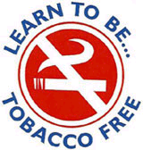C:\STOCKLAYOUTS\CURRENT PROJECTS\FN99803-PL\FN99803-IMG02.emf

*o*

*Treating Tobacco*

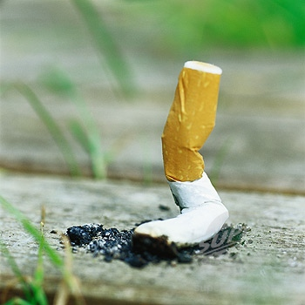

**Light breakfast and lunch to be provided by SCC**

**Faculty:**

Laura Giardino, MS, CNP

Linda Zajicek, MS, CNP

Janis Hurley, RN, LMSW

Debora Rippel, MA

Kathleen Flynn-Bisson, MA, CHES

*Dependence*

***Registration Deadline*: September 29, 2017 Email: Wanda.Ortiz@suffolkcountyny.gov OR**

**Remit to: Wanda Ortiz SCDHS, Office of Health Education,**

**FAX: 631-853-2958 PHONE: 631-853-4017 P.O. Box 6100, Bldg. C016, William J. Lindsay County Confirmation Letter with Directions Will Be Sent Complex, Hauppauge, NY 11788**

**PLEASE PRINT**

|  |  |
| --- | --- |
| Name: | Phone: |
| Address: | Email: |
| Agency: | Position: |

Attendance at this one day training will enable participants to:

* Describe the three aspects of nicotine dependence
* Provide appropriate motivational counseling
* Assist clients/consumers to make a quit plan
* Learn behavior change strategies
* Discuss the 7 FDA approved medications to treat nicotine

dependence

* Integrate relapse prevention into treatment plan
* Provide cessation programs on site

**6.75 CASAC Credits**

*Suffolk County Department of Health Services*

*“Learn To Be…Tobacco Free” Program in cooperation with*

*NYS OASAS and the Suffolk Care Collaborative (SCC)*

**Location:**

**Suffolk Care Collaborative**

**1393 Veterans Memorial Highway**

**Hauppauge, NY 11788**